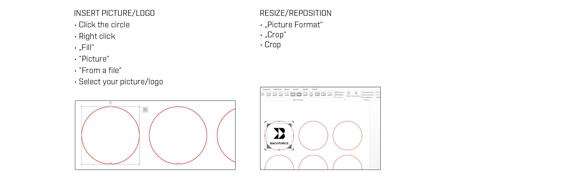
USE YOUR OWN DESIGN/LOGO

